The Bennett Post-Occlusion Skin Injury Scale (BPOSIS): A Proposed Classification and Management Framework for Skin Injury Following Dermal Filler Vascular Occlusion
Stephanie Bennett RN, BSc (Hons), MSc
Stephanie Bennett Aesthetics & Skin
ORCID: 0009-0009-8305-3995

Abstract
Background: Dermal filler procedures are widely performed in aesthetic medicine. Although generally safe, vascular occlusion remains one of the most significant complications and may result in tissue ischaemia and subsequent skin injury. Current guidance primarily focuses on restoring perfusion, with limited structured guidance on the management of post-occlusion skin injury.
Objective: To propose a classification system and clinical management framework for skin injury following dermal filler vascular occlusion.
Methods: The Bennett Post-Occlusion Skin Injury Scale (BPOSIS) was developed using wound healing principles, published literature on dermal filler complications, and commonly observed patterns of ischaemic skin injury.
Results: The BPOSIS framework classifies post-occlusion skin injury into five grades ranging from ischaemia without tissue damage to full-thickness necrosis. Each grade is associated with clinical features and recommended wound care strategies.
Conclusion: The BPOSIS provides a structured clinical approach for assessing and managing post-vascular occlusion skin injury. Adoption of a standardised grading system may support practitioner education and improve clinical documentation.

Introduction
Dermal filler injections are among the most frequently performed procedures in aesthetic medicine. Hyaluronic acid fillers are widely used for facial rejuvenation and contouring. While complications are uncommon when performed by trained clinicians, vascular occlusion remains a recognised risk.
Vascular compromise may occur through intravascular injection or external compression of vessels, resulting in reduced blood supply to surrounding tissues. Early recognition and intervention are essential to restore perfusion and prevent tissue necrosis.
Current clinical protocols emphasise rapid treatment of vascular occlusion, including administration of hyaluronidase and supportive measures. However, following restoration of perfusion, clinicians may still encounter a range of skin injuries due to previous ischaemia. At present, there is limited structured guidance for classifying or managing these injuries.
The Bennett Post-Occlusion Skin Injury Scale (BPOSIS) is proposed as a clinical framework to classify the severity of post-occlusion skin injury and guide wound management.

Methods / Framework Development
The BPOSIS framework was developed through consideration of wound healing principles, published literature describing dermal filler vascular complications, and clinical patterns observed in ischaemic skin injury. The framework categorises skin injury following vascular occlusion into five progressive stages.

Figure 1. BPOSIS Classification Flowchart
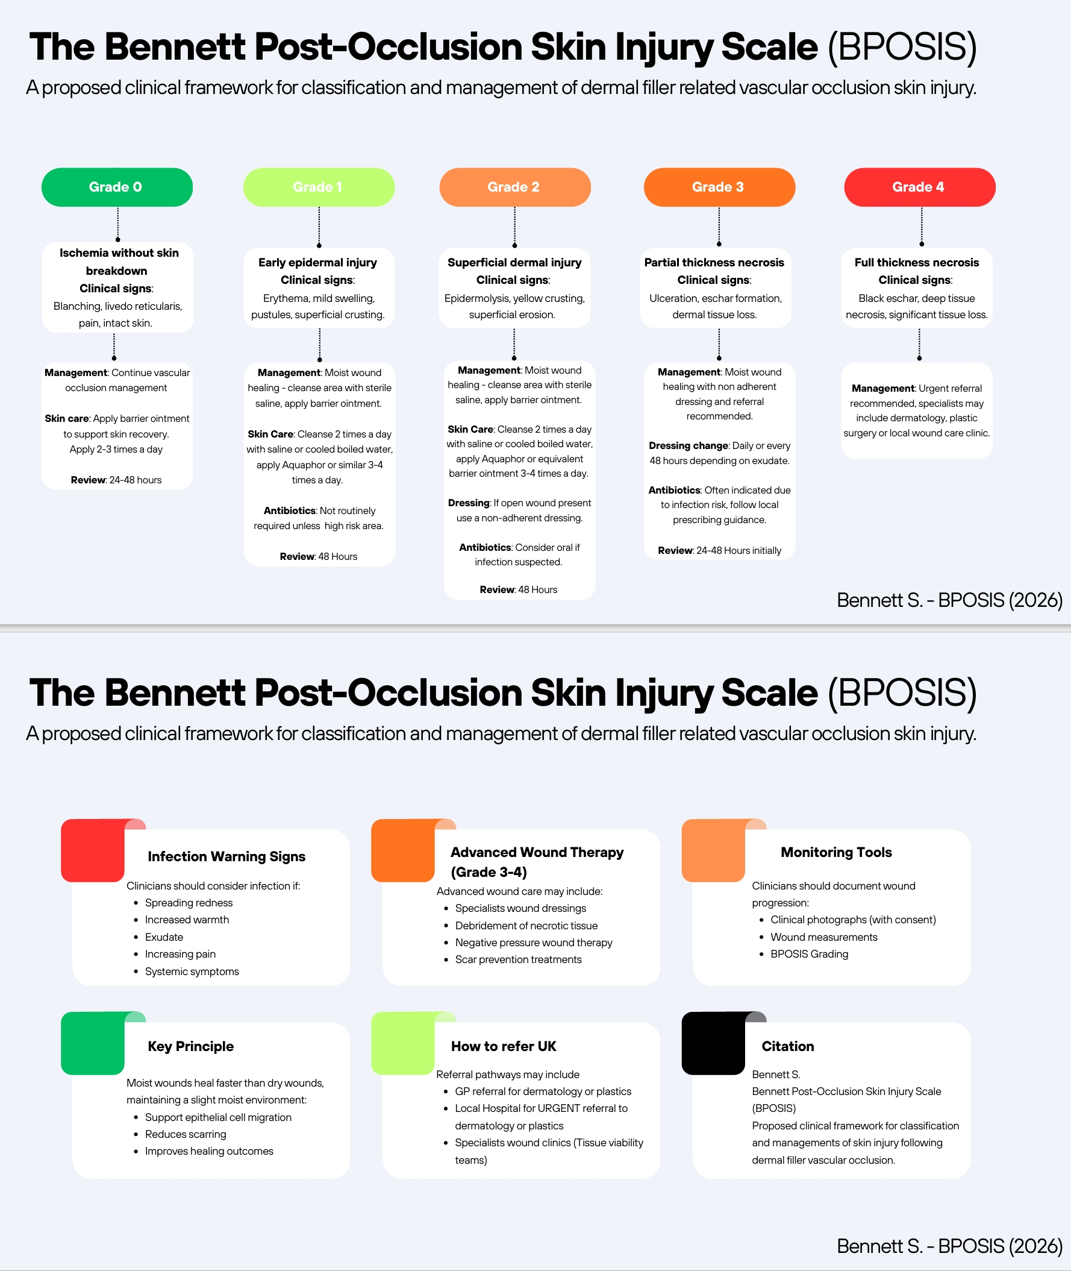

Clinical Characteristics
Grade 0: Blanching, livedo reticularis, and pain with intact skin.
Grade 1: Erythema, mild oedema, pustules, and superficial crusting.
Grade 2: Epidermolysis, superficial erosions, and yellow crusting indicating superficial dermal involvement.
Grade 3: Ulceration, eschar formation, and dermal tissue loss.
Grade 4: Full thickness necrosis with black eschar and deep tissue loss.

Management Principles
Management of post-occlusion skin injury focuses on maintaining a moist wound environment, protecting fragile tissue, preventing infection, and supporting epithelial regeneration. Barrier ointments such as Aquaphor (a petrolatum-based healing ointment) may be used to maintain a moist wound environment and support epidermal repair, while non-adherent dressings can protect compromised skin in cases of epidermal breakdown.

Discussion
The BPOSIS framework provides clinicians with a structured method of recognising and documenting skin injury following vascular occlusion. By categorising injury severity, practitioners may more easily determine appropriate wound care strategies and communicate findings with other clinicians.
Standardised classification systems have been widely adopted across medicine to improve consistency of clinical assessment. In aesthetic medicine, a similar framework may support complication management education and improve documentation of outcomes.

Conclusion
The Bennett Post-Occlusion Skin Injury Scale (BPOSIS) is proposed as a practical clinical framework for classifying and managing skin injury following dermal filler vascular occlusion. Further research may help evaluate its clinical utility and potential role in practitioner education.

References
DeLorenzi C. (2017). Complications of injectable fillers, part 2: vascular complications. Aesthetic Surgery Journal.
Signorini M et al. (2016). Global Aesthetics Consensus: Avoidance and management of complications from hyaluronic acid fillers. Plastic and Reconstructive Surgery.
Pavicic T et al. (2019). Injectable fillers: complications and management. Journal of Cosmetic Dermatology.
Wang LL et al. (2021). Vascular complications following dermal filler injections. Dermatological Surgery.
Goodman GJ et al. (2020). Management of dermal filler complications. Dermatologic Therapy.
Urdiales-Gálvez F et al. (2018). Treatment of soft tissue filler complications: expert consensus recommendations. Aesthetic Plastic Surgery.
Leaper DJ et al. (2015). Appropriate use of topical antimicrobial agents in wounds. International Wound Journal.
Guest JF et al. (2020). Clinical outcomes and cost-effectiveness of wound care management. Journal of Wound Care.
Dowsett C & Newton H. (2019). Wound bed preparation: TIME framework revisited. Wounds UK.
European Wound Management Association (EWMA). (2017). Position Document: Advanced wound care.

